Letter Template to Parent/Guardians

Dear Parent/Caregiver,

Your young person is being invited to participate in a unique outback learning experience called Operation Flinders. The program (referred to as an Exercise) provides young people aged roughly 14-18 with opportunities to develop team skills, personal strengths, and resilience, as well as learning bush survival skills and enjoying exciting challenges while walking in the Flinders Ranges. More than 9000 young South Australians have participated over the past 30 years, many finding the experience rewarding and even life changing.

Activities will include:
- Bush cooking and camping
- Aboriginal cultural interaction
- Abseiling or High Ropes course
- Learning navigation and other bush skills
- Walking through the beautiful Flinders Ranges, enjoying nature, night skies, sunsets etc. with ample time for talking, discussions about future directions, current concerns, problem solving and life choices
- Huge opportunities for potential growth, inspiration, development, change and encouragement.

We have put together a short video that provides a snippet of what it is like to be a participant on an Operation Flinders exercise and wanted to share with you for context. You can view this on YouTube by clicking here.

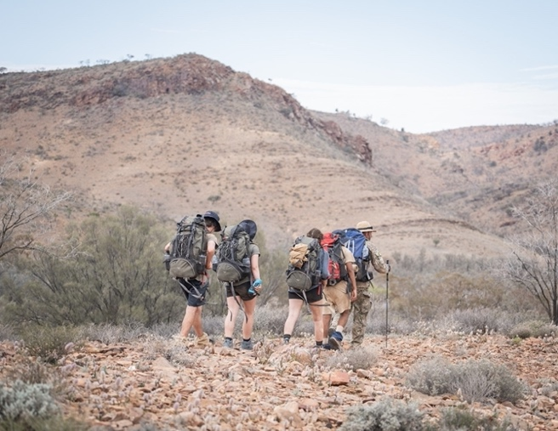
Acknowledgement of Country
The Operation Flinders Exercise takes place on Yankaninna Station on Adnyamathanha Country and the office and warehouse are located on Kaurna country.

Operation Flinders Foundation acknowledges that the Adnyamathanha people are the traditional custodians of the Country on which we work, Yankaninna Station.

Operation Flinders recognises that ‘Country’ incorporates the land, water, and sky. It is also the blood, spirit, creation stories, teachings, and lore of Aboriginal people. We pay our respect to this connection, as well as to the Elders, past and present.

Yankaninna Station is 600km north of Adelaide is in the northern Flinders Ranges, east of Copley & Leigh Creek.

Care and Supervision
Teams comprise of 10 young people, 2 Operation Flinders Team Leaders and 2 School/Agency Support Staff. Some teams may also have a Peer Group Mentor, who is a previous participant trained as a mentor for a new team.

Each team remains independent of other teams and each young person carries their own personal and sleeping gear.
The teams move from one night location to the next, where food and cooking gear are stored. The actual route is chosen by the Team Leader according to the capabilities of the young people.

The terrain is rugged and unspoiled, though campsites sometimes have long-drop toilets. A fire is used for warmth and cooking, and shelters are erected each night.

Teams spend 7 nights/8 days together, accompanied at all times by the adults from their school/agency who have a duty of care. Support Staff are on call at all times.

All Team Leaders have Provide First Aid qualifications, National Police Checks, DHS Working with Children checks and undergo rigorous field training.

Qualified paramedics from First Care are on site and have suitable vehicles for attending to any and all emergencies. Our Base camp also has telephone contact with the Royal Flying Doctor Service should further medical assistance be required.

Permissions & Documentation
This program is physically demanding so a medical disclosure completed by a parent/caregiver is required to participate. The medical information is only made available to Operation Flinders personnel to review and access in the unlikely event of an emergency.

Your school/agency coordinator will be able to provide you with the forms required, either in hardcopy or electronic format. Operation Flinders would prefer all forms to be done using the online system, however, you can use the paper version if needed. They will also be able to let you know when the medical and consent form need to be returned by.

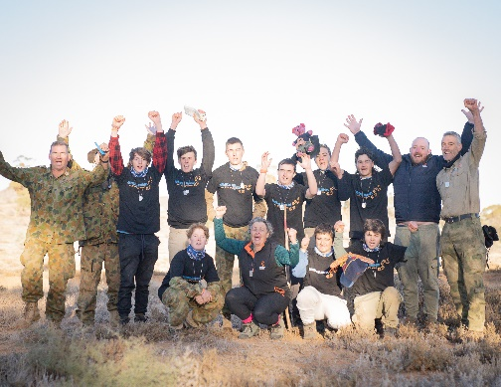
Packing List
Attached to this letter is a packing list that your young person is asked to organise to ensure they have the right equipment to assist them throughout this experience. The items listed in blue are either supplied or loaned to your young person by Operation Flinders. The items in green are not critical but are suggested options for you and/or your young person to consider.

In the first instance, if there are any issues in obtaining items from this packing list, please speak with your school/agency coordinator who can look to assist.

Transport
Your school or agency coordinator is responsible for transport to and from the exercise. If needed, Operation Flinders has several 4WD vehicles with competent drivers in the area to transport your young person.

Media
The media takes a keen interest in Operation Flinders and occasionally public figures visit the exercises. Should you object to your child being photographed or interviewed, be sure to indicate that on the consent form.

Further Information
Please discuss with your school or agency coordinator if you require more information about the experience.

Alternatively, you can learn more about Operation Flinders via our website - https://operationflinders.org.au/exercises

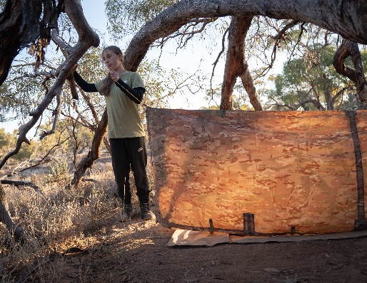 | 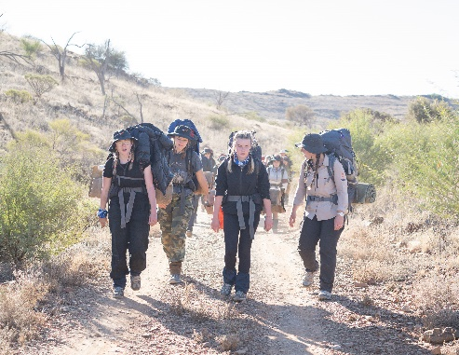 | 